**SETUP GUIDELINES**

1. Import the inworld package into unity. This is done by clicking:

Assets 🡪 Import Package 🡪 Custom Package

1. Select the inworld package and click ‘Open’. TH package could be downloaded from the below link:

<https://github.com/inworld-ai/inworld-unity-sdk/releases/>

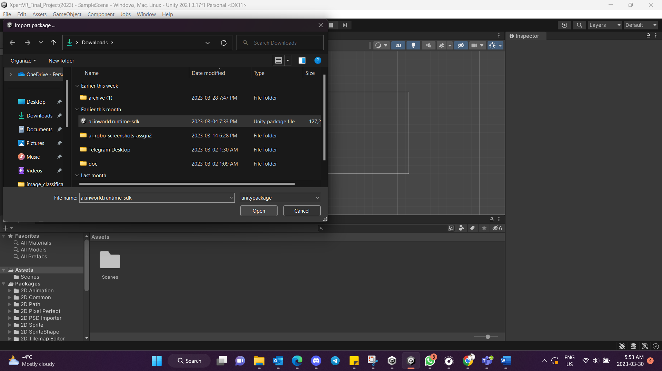

1. In the ‘Import Unity Package’ window, select all options and click on ‘Import’.

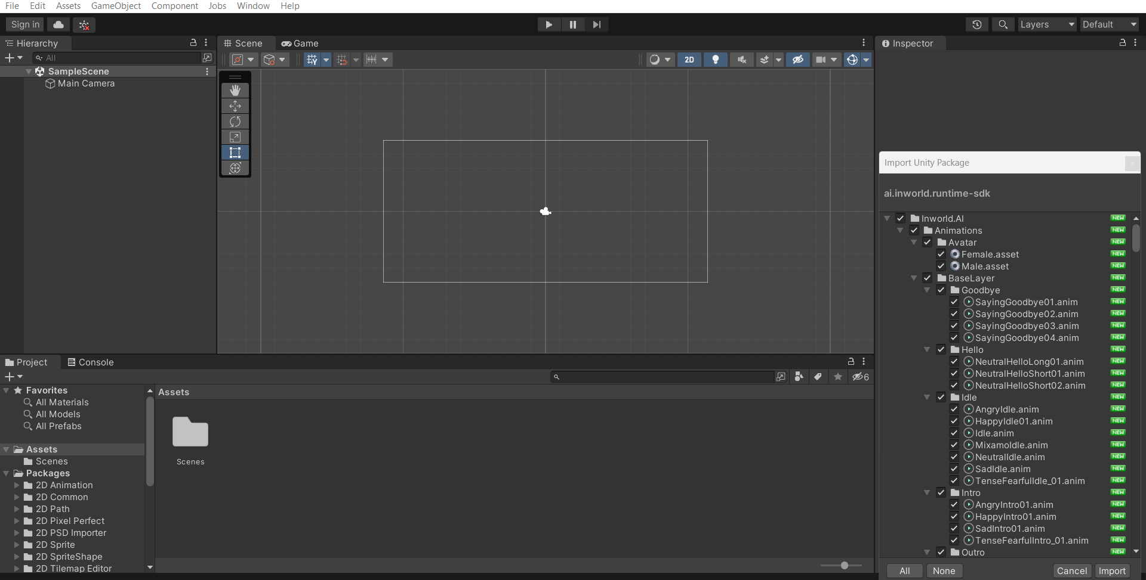

1. The package will be imported to the unity.

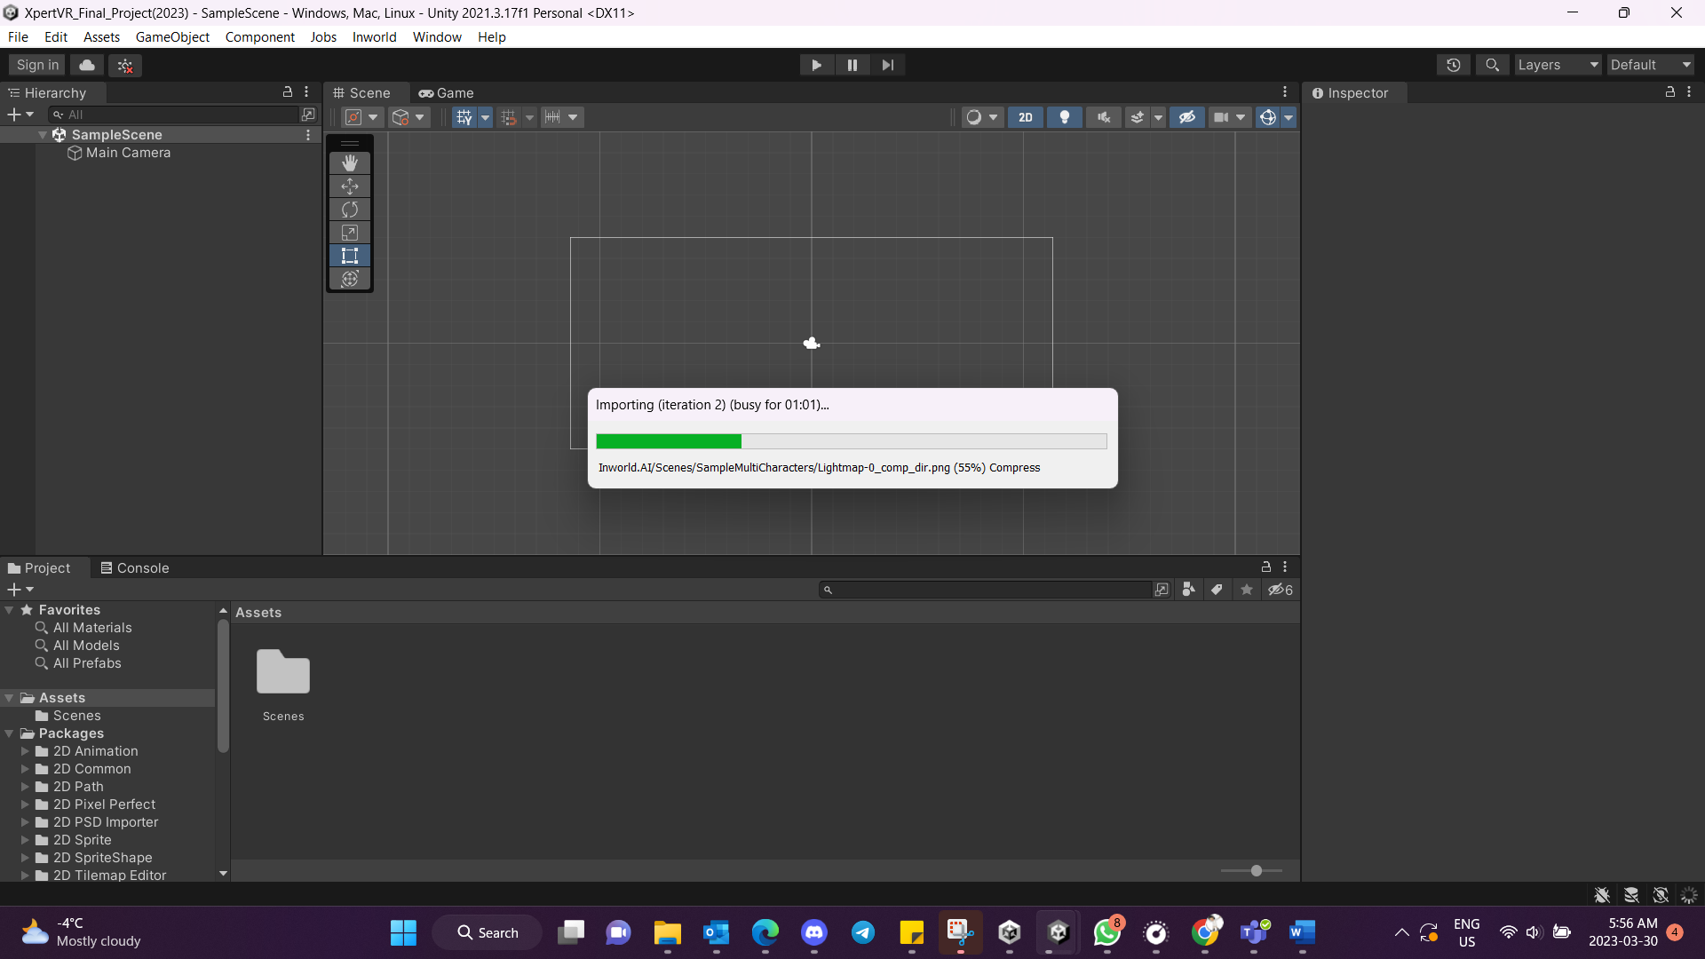

1. The window appears like this:



1. Now we have to connect our inworld account to access the NPCs and their features. For that select:

Inworld 🡪 Studio Panel

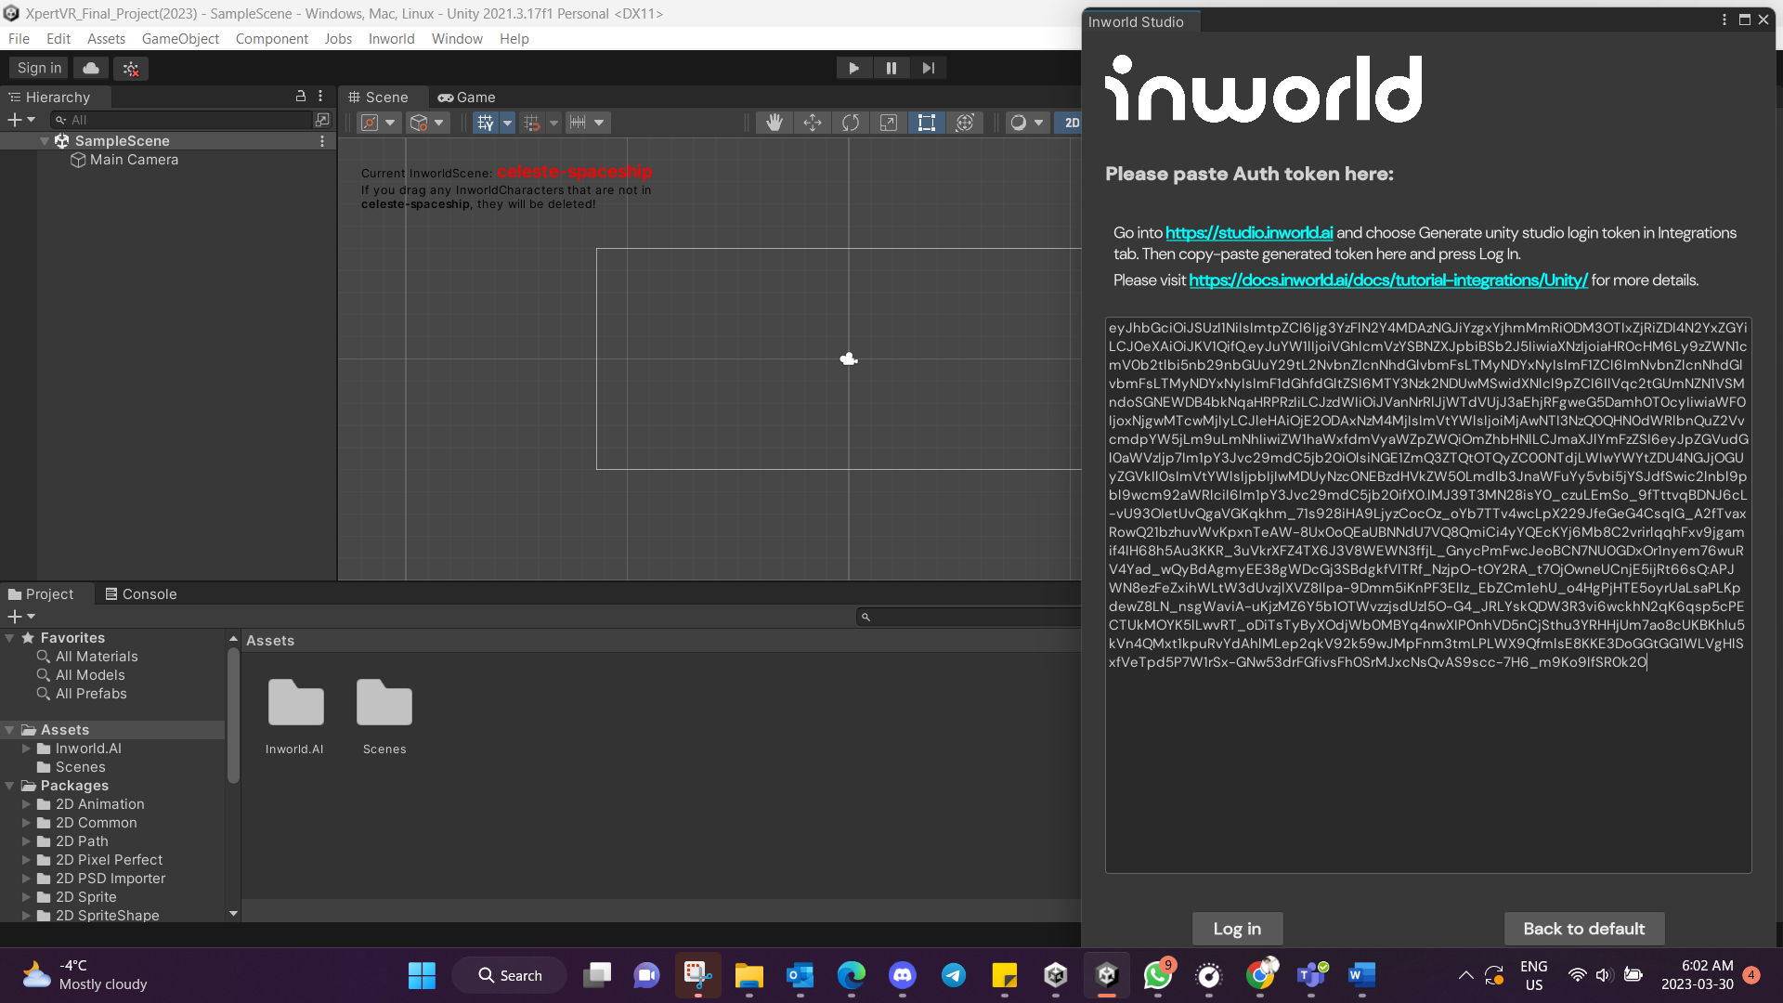

1. Now the window could be closed and within then we could access the Avatars within the below folder.

Assets 🡪 Inworld.AI 🡪 <user_folder_name> 🡪 Avatars.